**Using VRF To Split Traffic Between Two EIGRP Networks**

**Austin Tran-Struthers**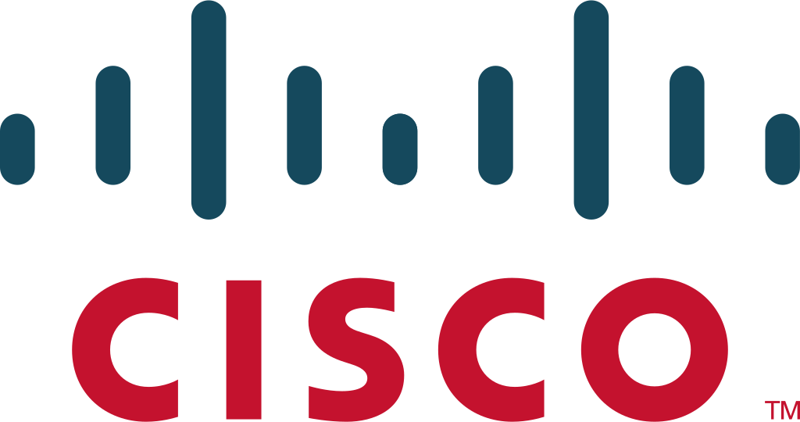  
  
  
**Purpose**

To learn about how VRF works and how to configure it with EIGRP so that both sides of the network work properly.

**Background**

The Virtual Routing and Forwarding (VRF) protocol is a technology used in computer networking that allows multiple routing tables to be used within a single router. It was introduced by Cisco Systems in 1999 as part of their MPLS architecture.

Before VRF, routers could only have one global routing table, which meant that all traffic was treated equally and could potentially leak between different virtual networks. With VRF, each virtual network can have its own routing table and routing policies, enabling multiple isolated virtual networks to share a single physical network infrastructure.

VRF technology has since become an essential component of many different network designs, especially in large scale enterprise networks where multiple independent organizations share the same physical infrastructure. It is also widely used in service provider networks to provide virtual private networks (VPNs) to their customers.

The VRF protocol operates at layer 3 of the OSI model and is implemented using techniques such as route distinguishers and route targets. Route distinguishers are used to make the same IP address unique in different VRFs, while route targets are used to control which VRFs receive certain routes.

Overall, VRF is a powerful and flexible protocol that enables network administrators to efficiently manage multiple virtual networks within a single physical network infrastructure, while maintaining security and isolation between them.

**Network Topology**

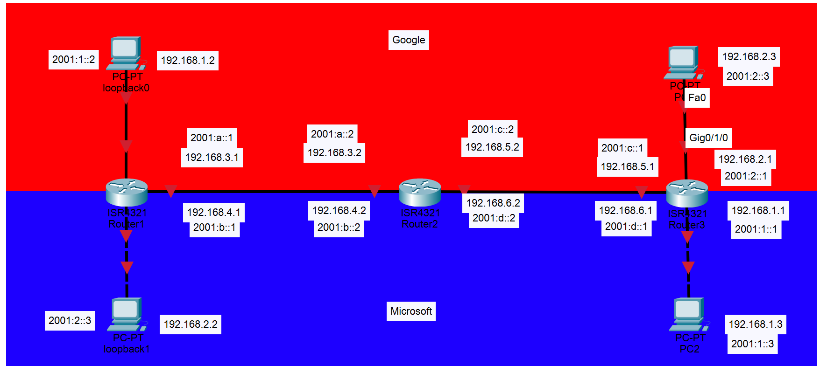**Lab Commands**

**vrf definition** creates the virtual router

**address-family [ipv4/6] unicast vrf [vrf name] autonomous-system [as number]** configures the address family for EIGRP

**Lab Summary**

In this lab we used VRF to split traffic between 2 different networks using the EIGRP routing protocol.

**Configurations  
Router 1:**

!

hostname R1

!

boot-start-marker

boot-end-marker

!

!

vrf definition Google

!

address-family ipv4

exit-address-family

!

address-family ipv6

exit-address-family

!

vrf definition Mgmt-intf

!

address-family ipv4

exit-address-family

!

address-family ipv6

exit-address-family

!

vrf definition Microsoft

!

address-family ipv4

exit-address-family

!

address-family ipv6

exit-address-family

!

!

no aaa new-model

!

!

!

!

login on-success log

!

!

!

!

!

!

!

subscriber templating

vtp domain cisco

vtp mode transparent

ipv6 unicast-routing

multilink bundle-name authenticated

!

!

!

crypto pki trustpoint TP-self-signed-859896477

enrollment selfsigned

subject-name cn=IOS-Self-Signed-Certificate-859896477

revocation-check none

rsakeypair TP-self-signed-859896477

!

!

crypto pki certificate chain TP-self-signed-859896477

certificate self-signed 01

3082032E 30820216 A0030201 02020101 300D0609 2A864886 F70D0101 05050030

30312E30 2C060355 04031325 494F532D 53656C66 2D536967 6E65642D 43657274

69666963 6174652D 38353938 39363437 37301E17 0D323231 30313731 38323635

385A170D 33303031 30313030 30303030 5A303031 2E302C06 03550403 1325494F

532D5365 6C662D53 69676E65 642D4365 72746966 69636174 652D3835 39383936

34373730 82012230 0D06092A 864886F7 0D010101 05000382 010F0030 82010A02

82010100 CA31EE51 C97FF58C 76C72B4E 2B6CD51B 98CBA177 7EEF8D11 DAAB7CA8

47B3AA97 3B815AD1 09F637AE B1D98BB8 A2CAA1A9 0AFAF87A 3AFBFF9E 34875D72

0BD5EE8D E40F4D4A 3B4A38A7 09F1940D 013C18AE F29F2BEA 07085EB5 982E9BC8

F99C8CA7 1C7DD58E 67B89FCB 951C3C4C 6D11B8C7 8D24BF5C 973A32BF E16A3094

99E8DB22 7FEA5A30 6E9457F6 90485336 E953F3D2 942824E3 87D8DE52 E00336AC

09CA85F0 0BD105FA B4078F96 9A2EA846 C147AD42 B08CD3D2 16A06EB1 CC54E167

8F4677E9 2663D37D 7B1C3891 9ABF4B5B 83ECE428 AD426108 357B992E 792C850D

84C67187 BF0E10B5 B1D23A97 F2F1372F 7D0FA8C8 80E947DE 5E0FA234 7FA6A487

24A0DB83 02030100 01A35330 51300F06 03551D13 0101FF04 05300301 01FF301F

0603551D 23041830 168014E7 C71AF39E FCC743E7 C7395603 DBBCA771 4C734E30

1D060355 1D0E0416 0414E7C7 1AF39EFC C743E7C7 395603DB BCA7714C 734E300D

06092A86 4886F70D 01010505 00038201 010029B2 769B6033 C71585B8 DD1EE596

BDB3F81C 5C58921E AF7FBE2F A95F447D 7B870BCD B9AE5E5D 46FCE0E1 667295B7

4668DACB F848F91A 207FC6CD 203E64BF 6747B9E7 6FF304F1 491442EA 56EEBEE6

DE79EC87 F5BE7B9C B2482264 A58FAC1B 827F66C7 F16C0292 815AD1ED 86F2E167

9568FC20 9E2ADCB6 311B34E4 E93EC128 2DD25078 4F27E1F1 4DD309BA B2A0248A

C41F66C8 4A81C2B8 9D0E8A62 4E0443F6 F28B3203 28A14D43 0E06A98B 06DAB16D

66E0616A DB63132A 8FB53D9B 88A28660 F84CD05D EC8653F6 C3FC6446 94977DAC

0ED87E1C 9C0B372A 6E25729B FAD2B249 6FDF7BC6 3218B110 D167D3D5 AEACB17D

6E8CB48E ED168D18 8D9104DE BA9F3515 5662

quit

!

license udi pid ISR4321/K9 sn FLM240608PJ

no license smart enable

diagnostic bootup level minimal

!

spanning-tree extend system-id

!

!

!

!

redundancy

mode none

!

!

!

!

!

!

!

!

interface Loopback0

vrf forwarding Google

ip address 192.168.1.2 255.255.255.0

ipv6 address 2001:1::2/64

!

interface Loopback1

vrf forwarding Microsoft

ip address 192.168.2.2 255.255.255.0

ipv6 address 2001:2::3/64

!

interface GigabitEthernet0/0/0

no ip address

negotiation auto

!

interface GigabitEthernet0/0/0.1

encapsulation dot1Q 1 native

vrf forwarding Google

ip address 192.168.3.1 255.255.255.0

ipv6 address 2001:A::1/64

!

interface GigabitEthernet0/0/0.2

encapsulation dot1Q 2

vrf forwarding Microsoft

ip address 192.168.4.1 255.255.255.0

ipv6 address 2001:B::1/64

!

interface GigabitEthernet0/0/1

no ip address

shutdown

negotiation auto

!

interface GigabitEthernet0/1/0

no ip address

shutdown

negotiation auto

!

interface GigabitEthernet0/1/1

no ip address

shutdown

negotiation auto

!

interface GigabitEthernet0

vrf forwarding Mgmt-intf

no ip address

shutdown

negotiation auto

!

!

router eigrp Google

!

address-family ipv4 unicast vrf Google autonomous-system 1

!

topology base

exit-af-topology

network 192.168.1.0

network 192.168.3.0

exit-address-family

!

address-family ipv6 unicast vrf Google autonomous-system 1

!

topology base

exit-af-topology

eigrp router-id 1.1.1.1

exit-address-family

!

!

router eigrp Microsoft

!

address-family ipv4 unicast vrf Microsoft autonomous-system 1

!

topology base

exit-af-topology

network 192.168.2.0

network 192.168.4.0

exit-address-family

!

address-family ipv6 unicast vrf Microsoft autonomous-system 1

!

topology base

exit-af-topology

eigrp router-id 1.1.1.1

exit-address-family

!

ip forward-protocol nd

ip http server

ip http authentication local

ip http secure-server

ip tftp source-interface GigabitEthernet0

!

!

!

!

!

!

control-plane

!

!

line con 0

transport input none

stopbits 1

line aux 0

stopbits 1

line vty 0 4

login

!

!

!

!

!

!

end

**Router 2**

!

hostname R1

!

boot-start-marker

boot-end-marker

!

!

vrf definition Google

!

address-family ipv4

exit-address-family

!

address-family ipv6

exit-address-family

!

vrf definition Mgmt-intf

!

address-family ipv4

exit-address-family

!

address-family ipv6

exit-address-family

!

vrf definition Microsoft

!

address-family ipv4

exit-address-family

!

address-family ipv6

exit-address-family

!

!

no aaa new-model

!

!

!

!

login on-success log

!

!

!

!

!

!

!

subscriber templating

vtp domain cisco

vtp mode transparent

ipv6 unicast-routing

multilink bundle-name authenticated

!

!

!

crypto pki trustpoint TP-self-signed-859896477

enrollment selfsigned

subject-name cn=IOS-Self-Signed-Certificate-859896477

revocation-check none

rsakeypair TP-self-signed-859896477

!

!

crypto pki certificate chain TP-self-signed-859896477

certificate self-signed 01

3082032E 30820216 A0030201 02020101 300D0609 2A864886 F70D0101 05050030

30312E30 2C060355 04031325 494F532D 53656C66 2D536967 6E65642D 43657274

69666963 6174652D 38353938 39363437 37301E17 0D323231 30313731 38323635

385A170D 33303031 30313030 30303030 5A303031 2E302C06 03550403 1325494F

532D5365 6C662D53 69676E65 642D4365 72746966 69636174 652D3835 39383936

34373730 82012230 0D06092A 864886F7 0D010101 05000382 010F0030 82010A02

82010100 CA31EE51 C97FF58C 76C72B4E 2B6CD51B 98CBA177 7EEF8D11 DAAB7CA8

47B3AA97 3B815AD1 09F637AE B1D98BB8 A2CAA1A9 0AFAF87A 3AFBFF9E 34875D72

0BD5EE8D E40F4D4A 3B4A38A7 09F1940D 013C18AE F29F2BEA 07085EB5 982E9BC8

F99C8CA7 1C7DD58E 67B89FCB 951C3C4C 6D11B8C7 8D24BF5C 973A32BF E16A3094

99E8DB22 7FEA5A30 6E9457F6 90485336 E953F3D2 942824E3 87D8DE52 E00336AC

09CA85F0 0BD105FA B4078F96 9A2EA846 C147AD42 B08CD3D2 16A06EB1 CC54E167

8F4677E9 2663D37D 7B1C3891 9ABF4B5B 83ECE428 AD426108 357B992E 792C850D

84C67187 BF0E10B5 B1D23A97 F2F1372F 7D0FA8C8 80E947DE 5E0FA234 7FA6A487

24A0DB83 02030100 01A35330 51300F06 03551D13 0101FF04 05300301 01FF301F

0603551D 23041830 168014E7 C71AF39E FCC743E7 C7395603 DBBCA771 4C734E30

1D060355 1D0E0416 0414E7C7 1AF39EFC C743E7C7 395603DB BCA7714C 734E300D

06092A86 4886F70D 01010505 00038201 010029B2 769B6033 C71585B8 DD1EE596

BDB3F81C 5C58921E AF7FBE2F A95F447D 7B870BCD B9AE5E5D 46FCE0E1 667295B7

4668DACB F848F91A 207FC6CD 203E64BF 6747B9E7 6FF304F1 491442EA 56EEBEE6

DE79EC87 F5BE7B9C B2482264 A58FAC1B 827F66C7 F16C0292 815AD1ED 86F2E167

9568FC20 9E2ADCB6 311B34E4 E93EC128 2DD25078 4F27E1F1 4DD309BA B2A0248A

C41F66C8 4A81C2B8 9D0E8A62 4E0443F6 F28B3203 28A14D43 0E06A98B 06DAB16D

66E0616A DB63132A 8FB53D9B 88A28660 F84CD05D EC8653F6 C3FC6446 94977DAC

0ED87E1C 9C0B372A 6E25729B FAD2B249 6FDF7BC6 3218B110 D167D3D5 AEACB17D

6E8CB48E ED168D18 8D9104DE BA9F3515 5662

quit

!

license udi pid ISR4321/K9 sn FLM240608PJ

no license smart enable

diagnostic bootup level minimal

!

spanning-tree extend system-id

!

!

!

!

redundancy

mode none

!

!

!

!

!

!

!

!

interface Loopback0

vrf forwarding Google

ip address 192.168.1.2 255.255.255.0

ipv6 address 2001:1::2/64

!

interface Loopback1

vrf forwarding Microsoft

ip address 192.168.2.2 255.255.255.0

ipv6 address 2001:2::3/64

!

interface GigabitEthernet0/0/0

no ip address

negotiation auto

!

interface GigabitEthernet0/0/0.1

encapsulation dot1Q 1 native

vrf forwarding Google

ip address 192.168.3.1 255.255.255.0

ipv6 address 2001:A::1/64

!

interface GigabitEthernet0/0/0.2

encapsulation dot1Q 2

vrf forwarding Microsoft

ip address 192.168.4.1 255.255.255.0

ipv6 address 2001:B::1/64

!

interface GigabitEthernet0/0/1

no ip address

shutdown

negotiation auto

!

interface GigabitEthernet0/1/0

no ip address

shutdown

negotiation auto

!

interface GigabitEthernet0/1/1

no ip address

shutdown

negotiation auto

!

interface GigabitEthernet0

vrf forwarding Mgmt-intf

no ip address

shutdown

negotiation auto

!

!

router eigrp Google

!

address-family ipv4 unicast vrf Google autonomous-system 1

!

topology base

exit-af-topology

network 192.168.1.0

network 192.168.3.0

exit-address-family

!

address-family ipv6 unicast vrf Google autonomous-system 1

!

topology base

exit-af-topology

eigrp router-id 1.1.1.1

exit-address-family

!

!

router eigrp Microsoft

!

address-family ipv4 unicast vrf Microsoft autonomous-system 1

!

topology base

exit-af-topology

network 192.168.2.0

network 192.168.4.0

exit-address-family

!

address-family ipv6 unicast vrf Microsoft autonomous-system 1

!

topology base

exit-af-topology

eigrp router-id 1.1.1.1

exit-address-family

!

ip forward-protocol nd

ip http server

ip http authentication local

ip http secure-server

ip tftp source-interface GigabitEthernet0

!

!

!

!

!

!

control-plane

!

!

line con 0

transport input none

stopbits 1

line aux 0

stopbits 1

line vty 0 4

login

!

!

!

!

!

!

end

**Router 3**

!

hostname R1

!

boot-start-marker

boot-end-marker

!

!

vrf definition Google

!

address-family ipv4

exit-address-family

!

address-family ipv6

exit-address-family

!

vrf definition Mgmt-intf

!

address-family ipv4

exit-address-family

!

address-family ipv6

exit-address-family

!

vrf definition Microsoft

!

address-family ipv4

exit-address-family

!

address-family ipv6

exit-address-family

!

!

no aaa new-model

!

!

!

!

login on-success log

!

!

!

!

!

!

!

subscriber templating

vtp domain cisco

vtp mode transparent

ipv6 unicast-routing

multilink bundle-name authenticated

!

!

!

crypto pki trustpoint TP-self-signed-859896477

enrollment selfsigned

subject-name cn=IOS-Self-Signed-Certificate-859896477

revocation-check none

rsakeypair TP-self-signed-859896477

!

!

crypto pki certificate chain TP-self-signed-859896477

certificate self-signed 01

3082032E 30820216 A0030201 02020101 300D0609 2A864886 F70D0101 05050030

30312E30 2C060355 04031325 494F532D 53656C66 2D536967 6E65642D 43657274

69666963 6174652D 38353938 39363437 37301E17 0D323231 30313731 38323635

385A170D 33303031 30313030 30303030 5A303031 2E302C06 03550403 1325494F

532D5365 6C662D53 69676E65 642D4365 72746966 69636174 652D3835 39383936

34373730 82012230 0D06092A 864886F7 0D010101 05000382 010F0030 82010A02

82010100 CA31EE51 C97FF58C 76C72B4E 2B6CD51B 98CBA177 7EEF8D11 DAAB7CA8

47B3AA97 3B815AD1 09F637AE B1D98BB8 A2CAA1A9 0AFAF87A 3AFBFF9E 34875D72

0BD5EE8D E40F4D4A 3B4A38A7 09F1940D 013C18AE F29F2BEA 07085EB5 982E9BC8

F99C8CA7 1C7DD58E 67B89FCB 951C3C4C 6D11B8C7 8D24BF5C 973A32BF E16A3094

99E8DB22 7FEA5A30 6E9457F6 90485336 E953F3D2 942824E3 87D8DE52 E00336AC

09CA85F0 0BD105FA B4078F96 9A2EA846 C147AD42 B08CD3D2 16A06EB1 CC54E167

8F4677E9 2663D37D 7B1C3891 9ABF4B5B 83ECE428 AD426108 357B992E 792C850D

84C67187 BF0E10B5 B1D23A97 F2F1372F 7D0FA8C8 80E947DE 5E0FA234 7FA6A487

24A0DB83 02030100 01A35330 51300F06 03551D13 0101FF04 05300301 01FF301F

0603551D 23041830 168014E7 C71AF39E FCC743E7 C7395603 DBBCA771 4C734E30

1D060355 1D0E0416 0414E7C7 1AF39EFC C743E7C7 395603DB BCA7714C 734E300D

06092A86 4886F70D 01010505 00038201 010029B2 769B6033 C71585B8 DD1EE596

BDB3F81C 5C58921E AF7FBE2F A95F447D 7B870BCD B9AE5E5D 46FCE0E1 667295B7

4668DACB F848F91A 207FC6CD 203E64BF 6747B9E7 6FF304F1 491442EA 56EEBEE6

DE79EC87 F5BE7B9C B2482264 A58FAC1B 827F66C7 F16C0292 815AD1ED 86F2E167

9568FC20 9E2ADCB6 311B34E4 E93EC128 2DD25078 4F27E1F1 4DD309BA B2A0248A

C41F66C8 4A81C2B8 9D0E8A62 4E0443F6 F28B3203 28A14D43 0E06A98B 06DAB16D

66E0616A DB63132A 8FB53D9B 88A28660 F84CD05D EC8653F6 C3FC6446 94977DAC

0ED87E1C 9C0B372A 6E25729B FAD2B249 6FDF7BC6 3218B110 D167D3D5 AEACB17D

6E8CB48E ED168D18 8D9104DE BA9F3515 5662

quit

!

license udi pid ISR4321/K9 sn FLM240608PJ

no license smart enable

diagnostic bootup level minimal

!

spanning-tree extend system-id

!

!

!

!

redundancy

mode none

!

!

!

!

!

!

!

!

interface Loopback0

vrf forwarding Google

ip address 192.168.1.2 255.255.255.0

ipv6 address 2001:1::2/64

!

interface Loopback1

vrf forwarding Microsoft

ip address 192.168.2.2 255.255.255.0

ipv6 address 2001:2::3/64

!

interface GigabitEthernet0/0/0

no ip address

negotiation auto

!

interface GigabitEthernet0/0/0.1

encapsulation dot1Q 1 native

vrf forwarding Google

ip address 192.168.3.1 255.255.255.0

ipv6 address 2001:A::1/64

!

interface GigabitEthernet0/0/0.2

encapsulation dot1Q 2

vrf forwarding Microsoft

ip address 192.168.4.1 255.255.255.0

ipv6 address 2001:B::1/64

!

interface GigabitEthernet0/0/1

no ip address

shutdown

negotiation auto

!

interface GigabitEthernet0/1/0

no ip address

shutdown

negotiation auto

!

interface GigabitEthernet0/1/1

no ip address

shutdown

negotiation auto

!

interface GigabitEthernet0

vrf forwarding Mgmt-intf

no ip address

shutdown

negotiation auto

!

!

router eigrp Google

!

address-family ipv4 unicast vrf Google autonomous-system 1

!

topology base

exit-af-topology

network 192.168.1.0

network 192.168.3.0

exit-address-family

!

address-family ipv6 unicast vrf Google autonomous-system 1

!

topology base

exit-af-topology

eigrp router-id 1.1.1.1

exit-address-family

!

!

router eigrp Microsoft

!

address-family ipv4 unicast vrf Microsoft autonomous-system 1

!

topology base

exit-af-topology

network 192.168.2.0

network 192.168.4.0

exit-address-family

!

address-family ipv6 unicast vrf Microsoft autonomous-system 1

!

topology base

exit-af-topology

eigrp router-id 1.1.1.1

exit-address-family

!

ip forward-protocol nd

ip http server

ip http authentication local

ip http secure-server

ip tftp source-interface GigabitEthernet0

!

!

!

!

!

!

control-plane

!

!

line con 0

transport input none

stopbits 1

line aux 0

stopbits 1

line vty 0 4

login

!

!

!

!

!

!

end

**Screenshots  
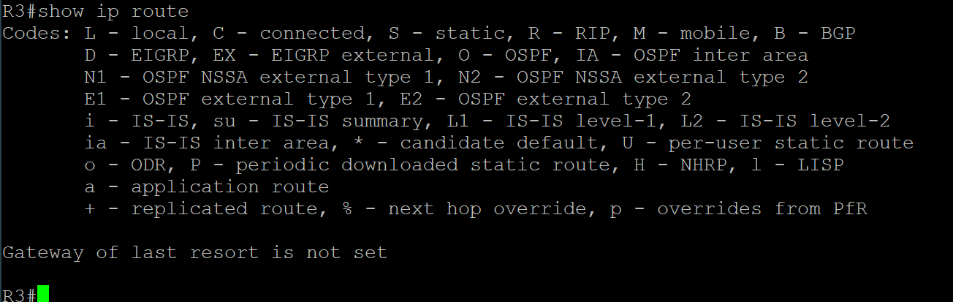  
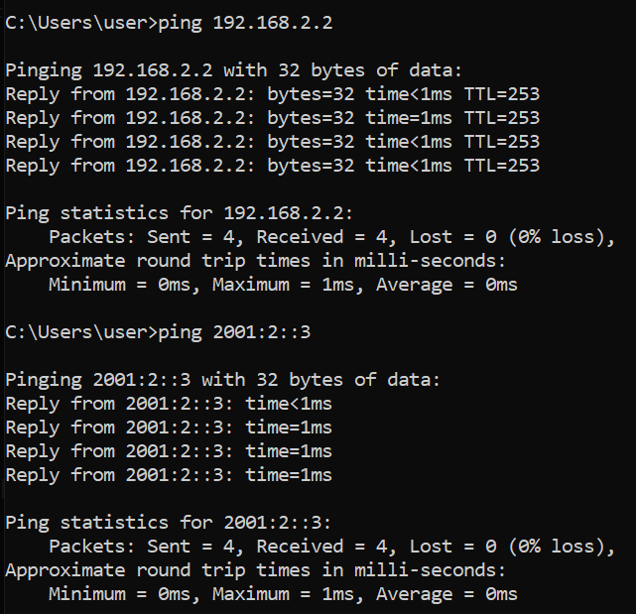**

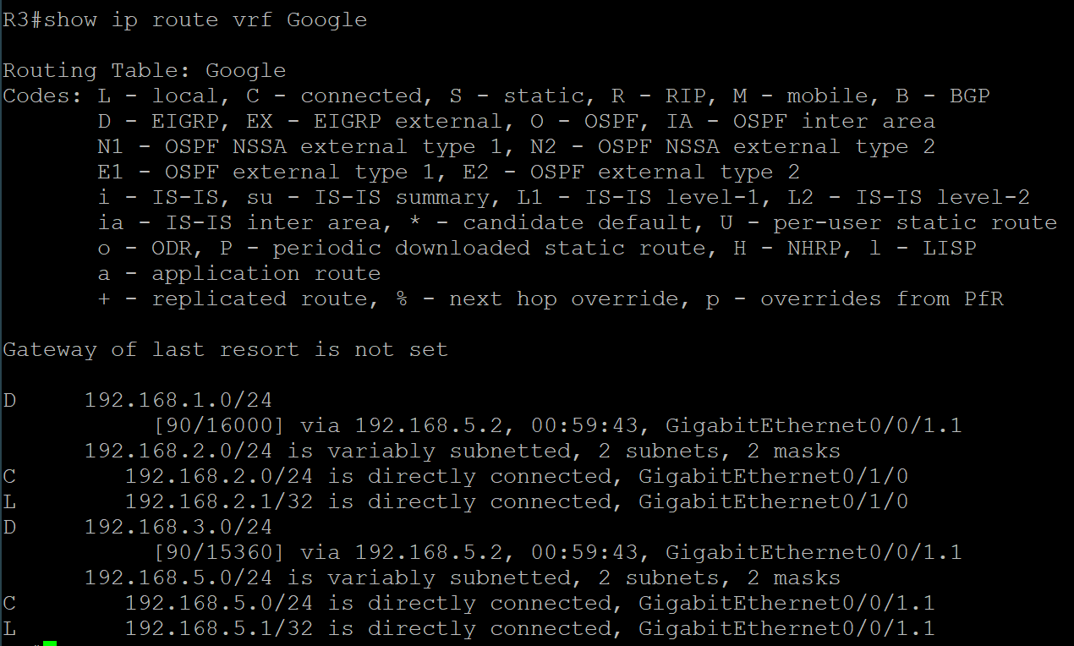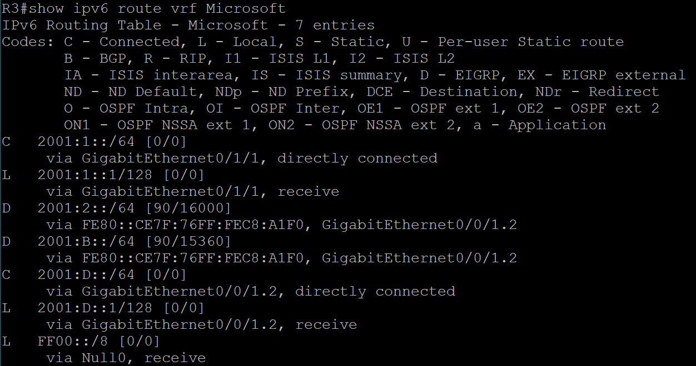**Problems**

The only problems we really had were

**Conclusion**

Overall I learned how to use VRF and how to apply it to this dual-EIGRP network.